***WEB PAGE BASED TEMPERATURE AND HUMIDITY MONITORING SYSTEM***

REPORT:

With the development of sensor technology and the development of society, the demand of intelligent level in industry, agriculture and other industries is increasing. In order to improve the intelligence of these industries, the temperature and humidity sensors are widely used in various industries, and the use of temperature and humidity sensors is becoming more and more scaled.

The temperature and humidity sensor is mainly used to measure the temperature and humidity of the environment or the equipment, which is usually used in occasions where the temperature and humidity is required, which also lays the wide acceptance of the temperature and humidity sensor using the industry .

The industry used by the temperature and humidity sensor has the following several kinds.

1. Agricultural planting

2. Animal husbandry

3. Storage of drugs and tobacco

4. Food Storage

5. Museum and Archives

6. Cold Chain Transportation Industry

7. Hospital

8. Automobile

9. Thermal power station

10. Buildings

11. Home Appliance

We done the project using ESP 32 Wi-Fi module

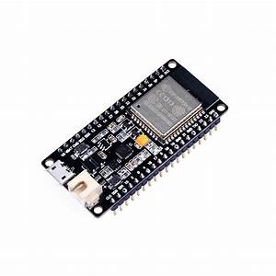

ESP32 is a series of low-cost, low-power system on a chip microcontrollers with integrated [Wi-Fi](https://en.wikipedia.org/wiki/Wi-Fi) and dual-mode [Bluetooth](https://en.wikipedia.org/wiki/Bluetooth).

We shown the values of temperature and humidity in the web page with the help of IP address shown in the serial when Wi-Fi is connected to the device.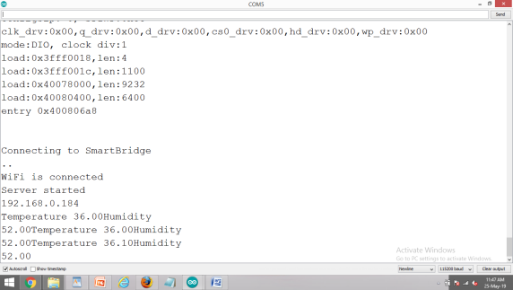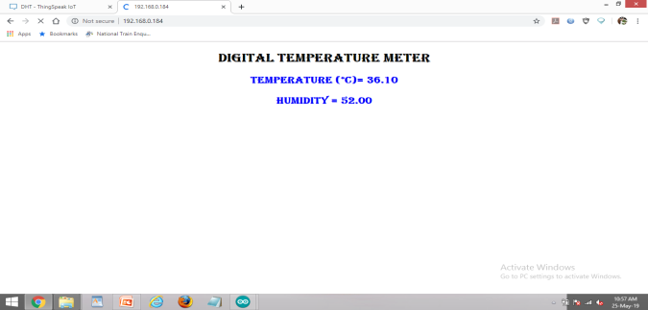

We also done this in the thingspeak, which displays the graph of temperature and humidity.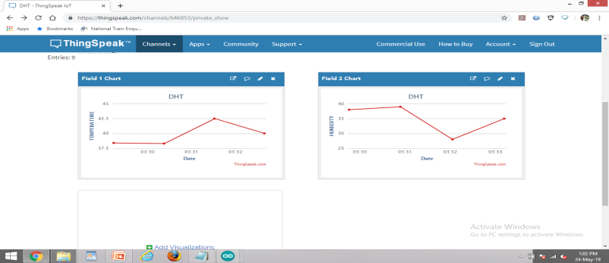

It can be seen that the temperature and humidity sensor has entered all walks of life deeply. It also brings great convenience to our life and industry.